**ASSIGNMENT: CREATE A WINDOWS DOMAIN**

Virtual machines to complete this assignment:

* A server machine with Windows Server 2019.
* A client machine with Windows 10.

# Installing the Active Directory in the Windows Server OS

You must complete the following steps in the server machine:

* + First, install the **Active Directory**.
  + Then, we must **promote** the server as a domain controller.

1. A local DNS service is required in order to complete the steps above. This service is automatically configured when promoting the server as a domain controller.
2. Assign namesurname.local as the domain name (the name and surname will correspond to the student completing the assignment. For example, johndoe.local or johnsmith.local).

**Active Directory: Install and Promote**

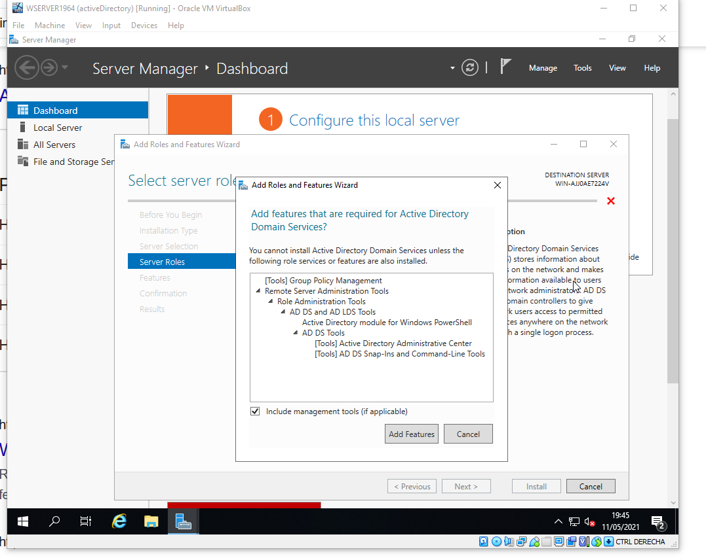 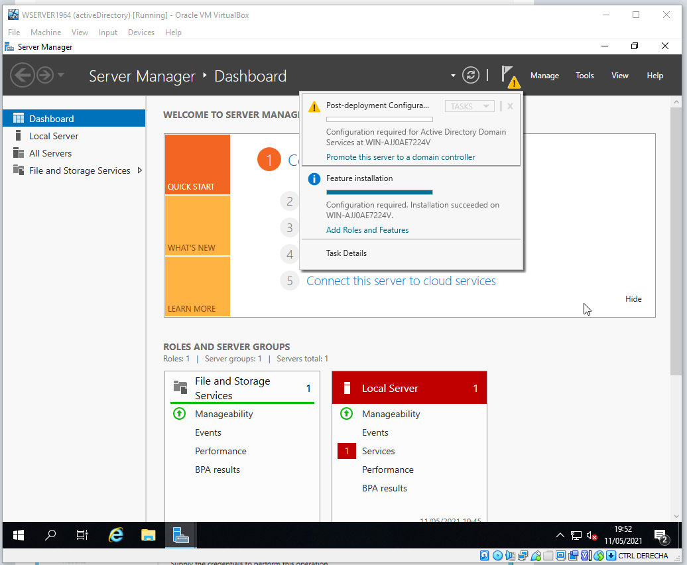

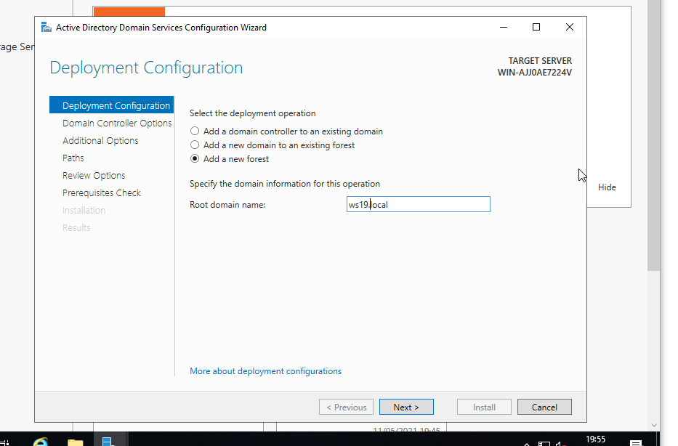 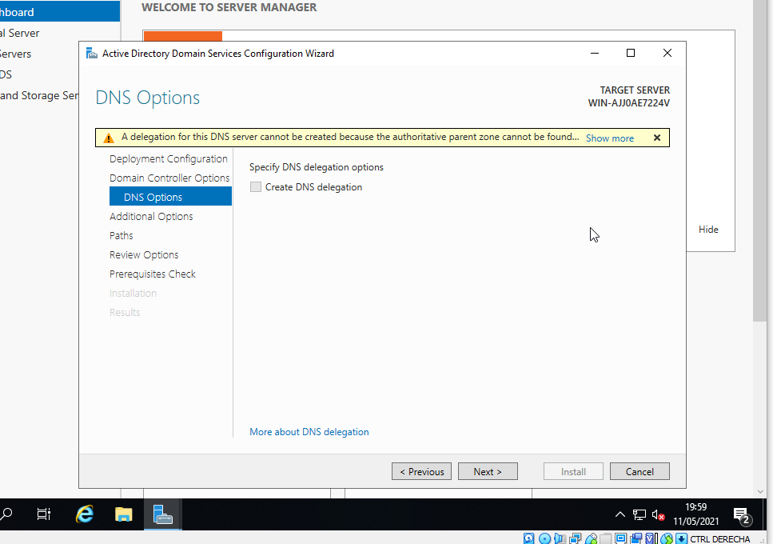

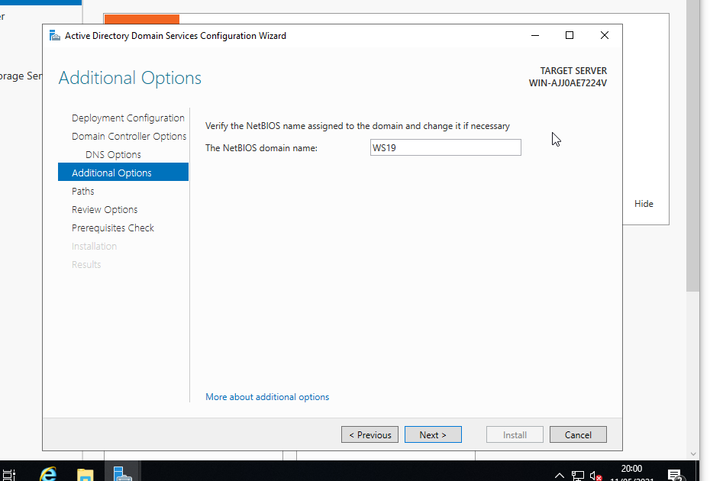

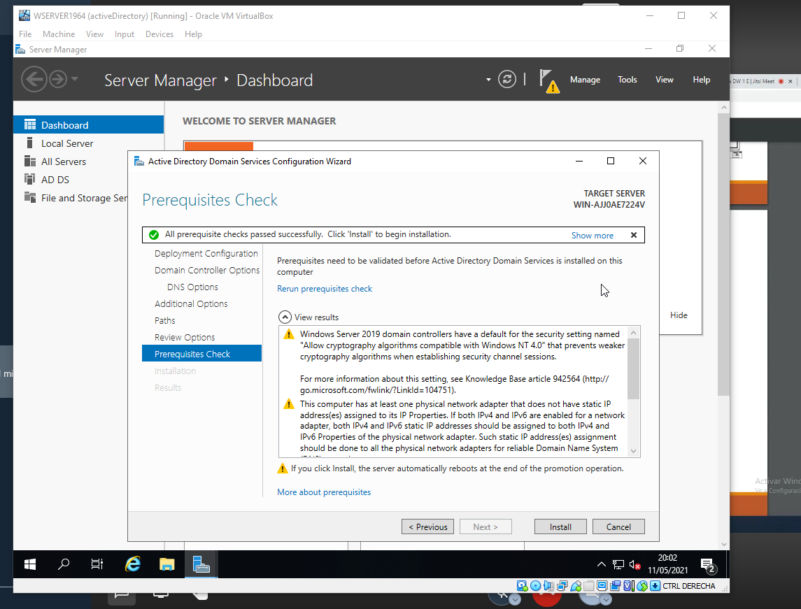

# Generating an Active Directory

From “Active Directory Users and Computers”, create the following objects:

* + An Organizational Unit (OU) whose name will be the name of a business invented by the students.

Then, create the following users and groups into the Organizational Unit you have previously created.

* + A group called **employees**, in which you will add the users below.
  + A user called **_template** with the address, telephones and the time permitted from Monday to Friday, from 9 a.m to 6 p.m.
  + Two standard users with the names: **johndoe** (John Doe will be the complete name) and **janeroe** (Jane Roe will be the complete name). You must create these two users copying the user **_template**

**Organizational Unit (OU).**

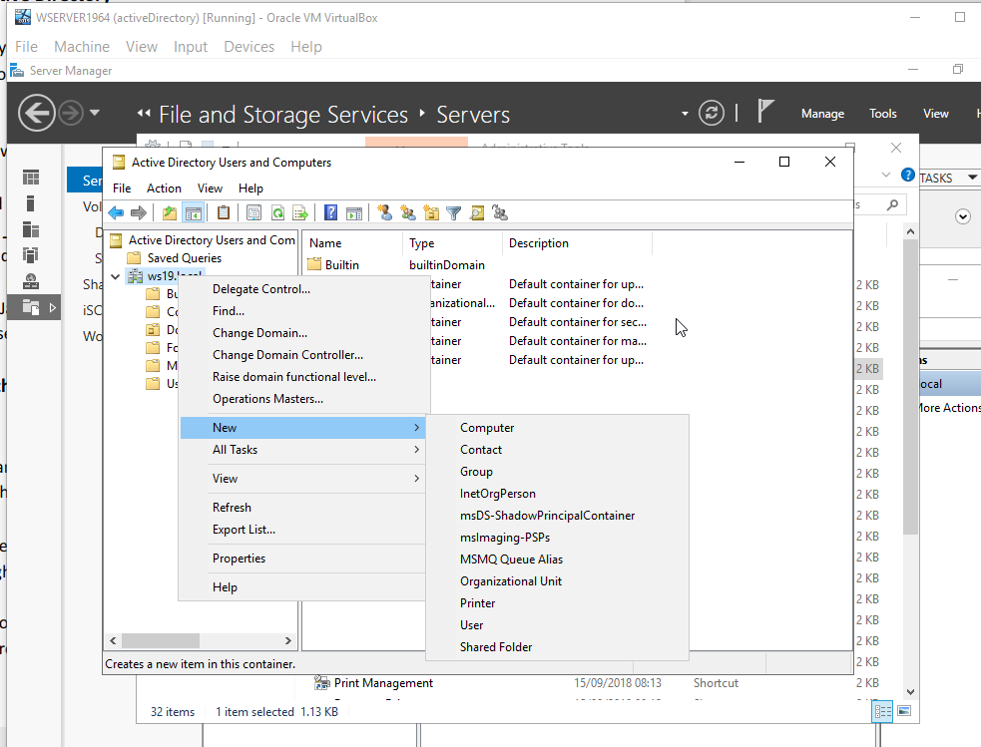

**Creating users and groups into the Organizational Unit.**

* + A group called **employees**, in which you will add the users below.
  + A user called **_template** with the address, telephones and the time permitted from Monday to Friday, from 9 a.m to 6 p.m.
  + Creating two standard users with the names: **johndoe** (John Doe will be the complete name) and **janeroe** (Jane Roe will be the complete name) copying the user **_template**.

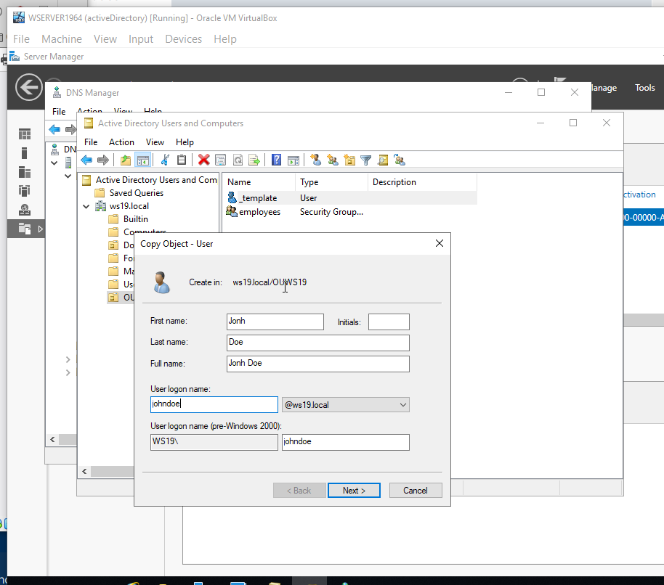 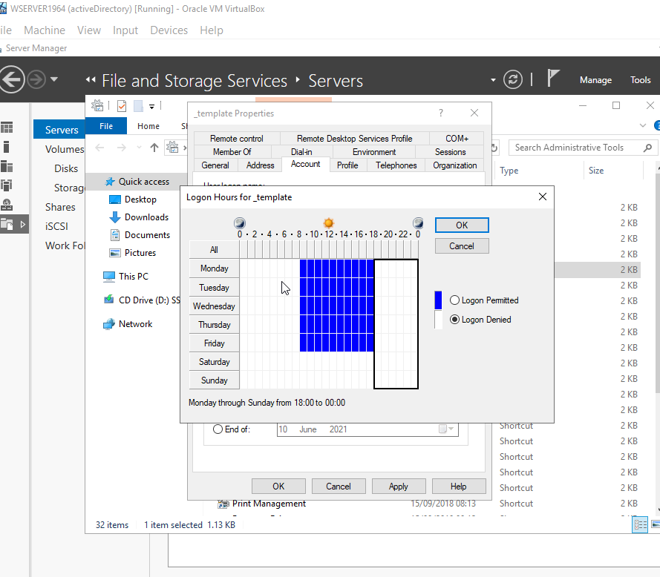

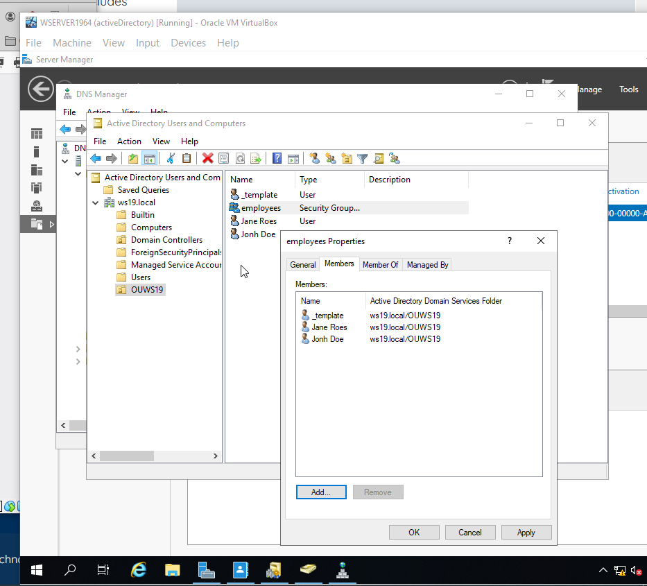

# Join in clients to the domain

Connect the client to the domain previously created. For this reason, the client and server must belong to the same network. In addition, you must create a user of the **computer** type from the server with the name of the client machine.

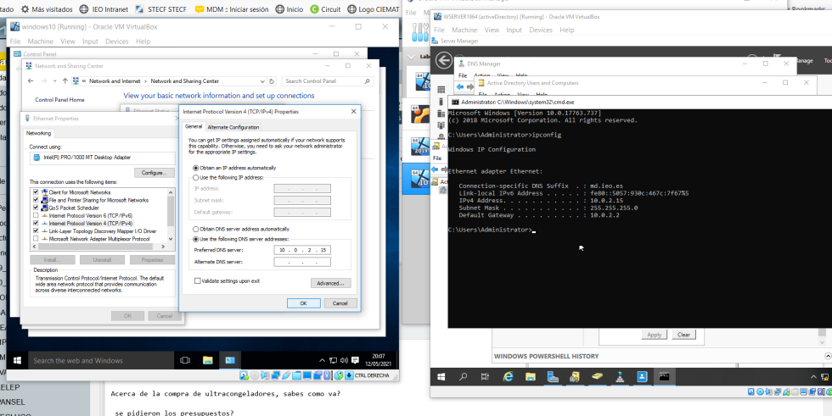

Then, from System Properties you will able to change the workgroup to a domain. Log in with an Administrator and reboot.

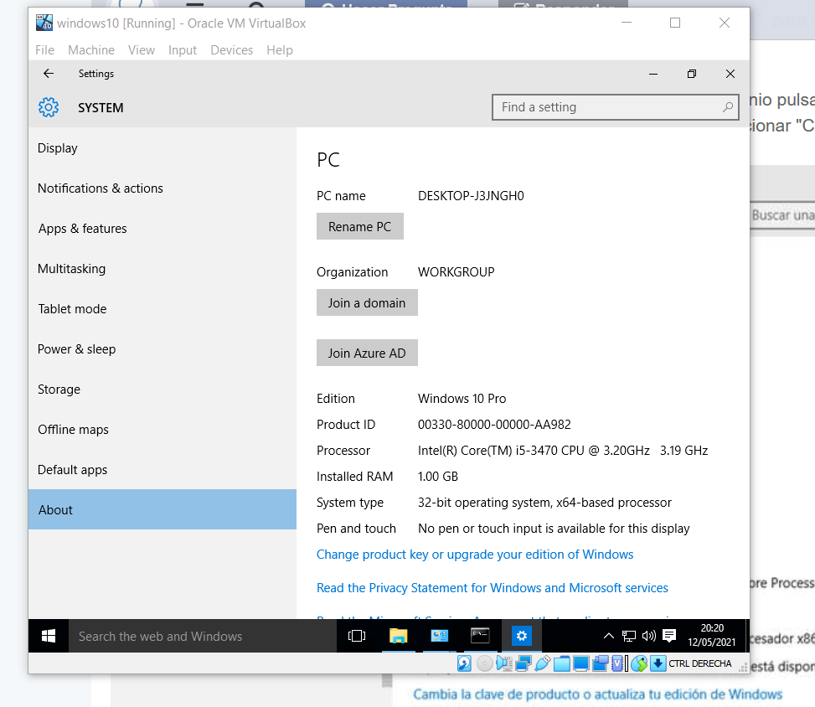 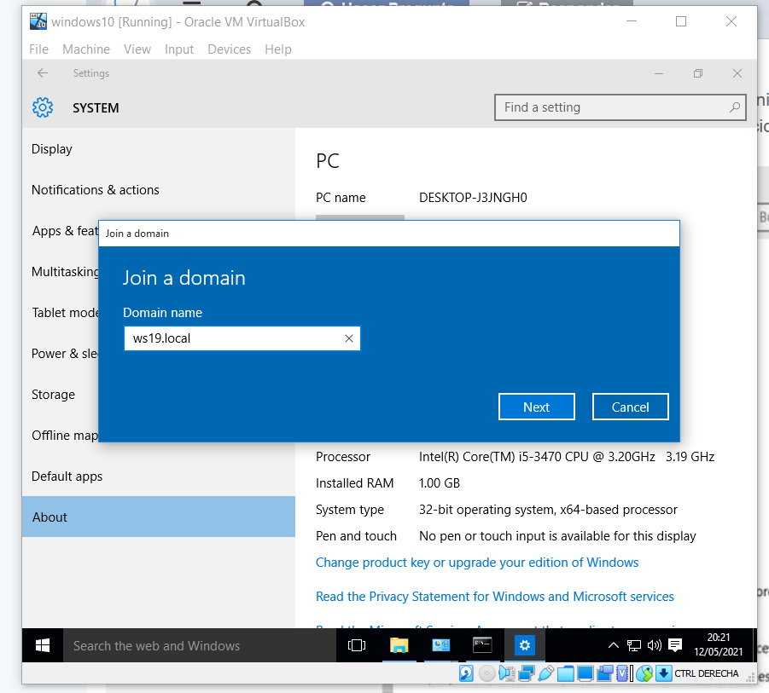

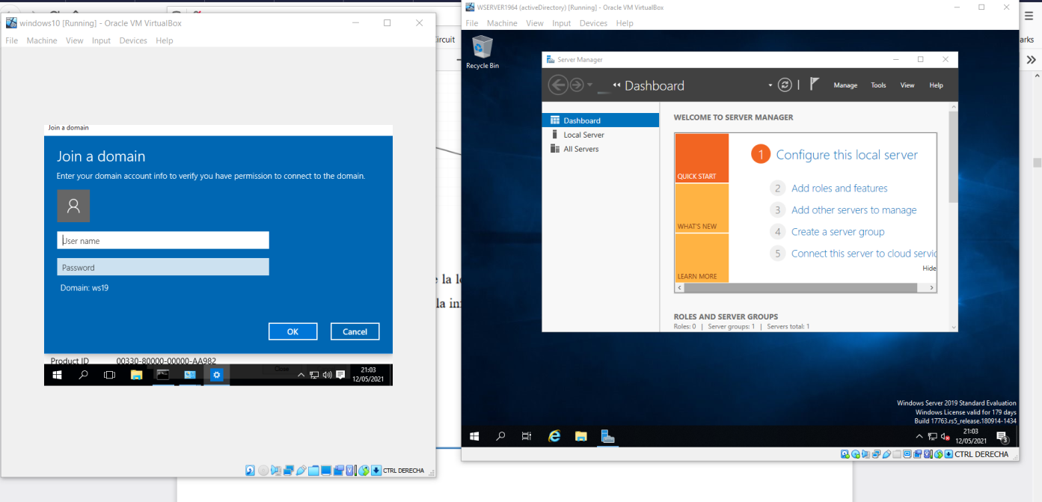 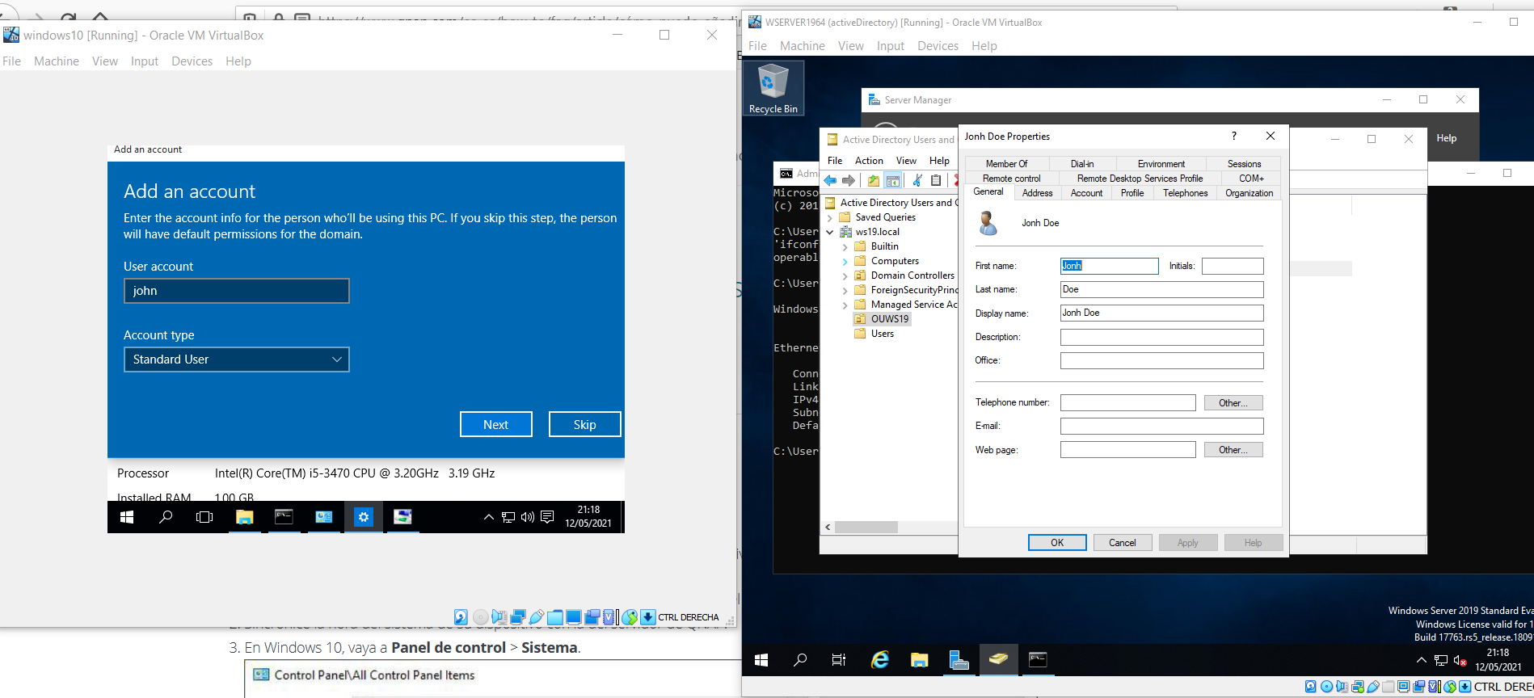

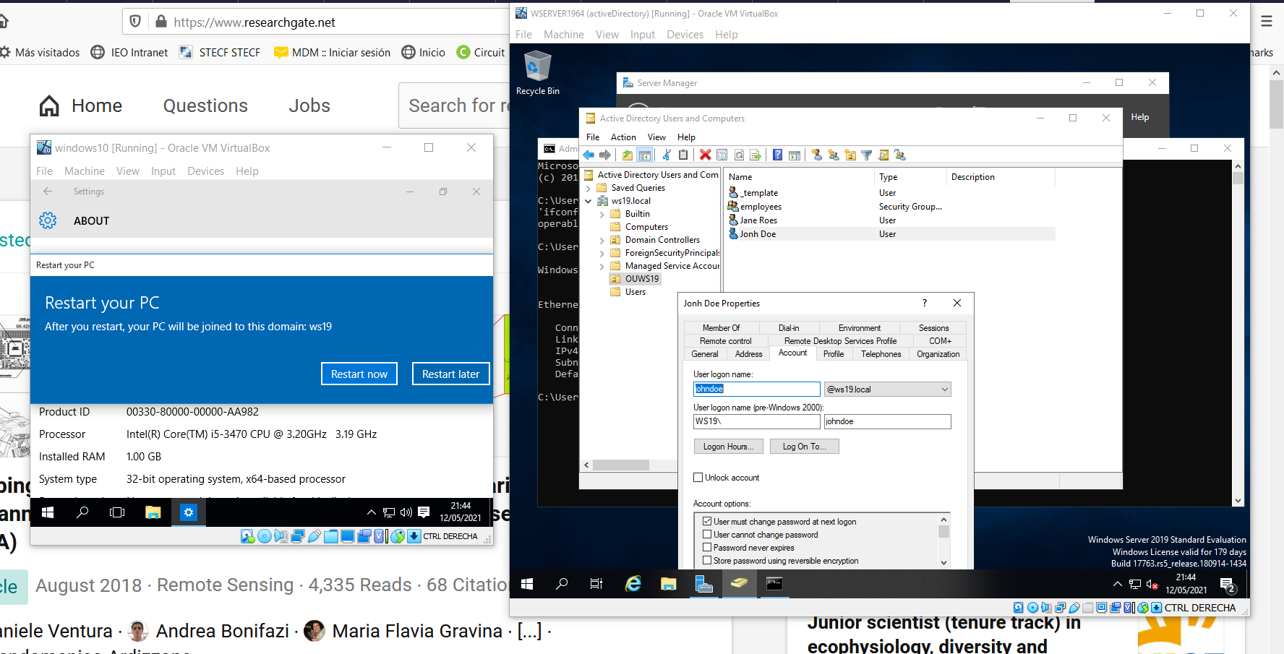 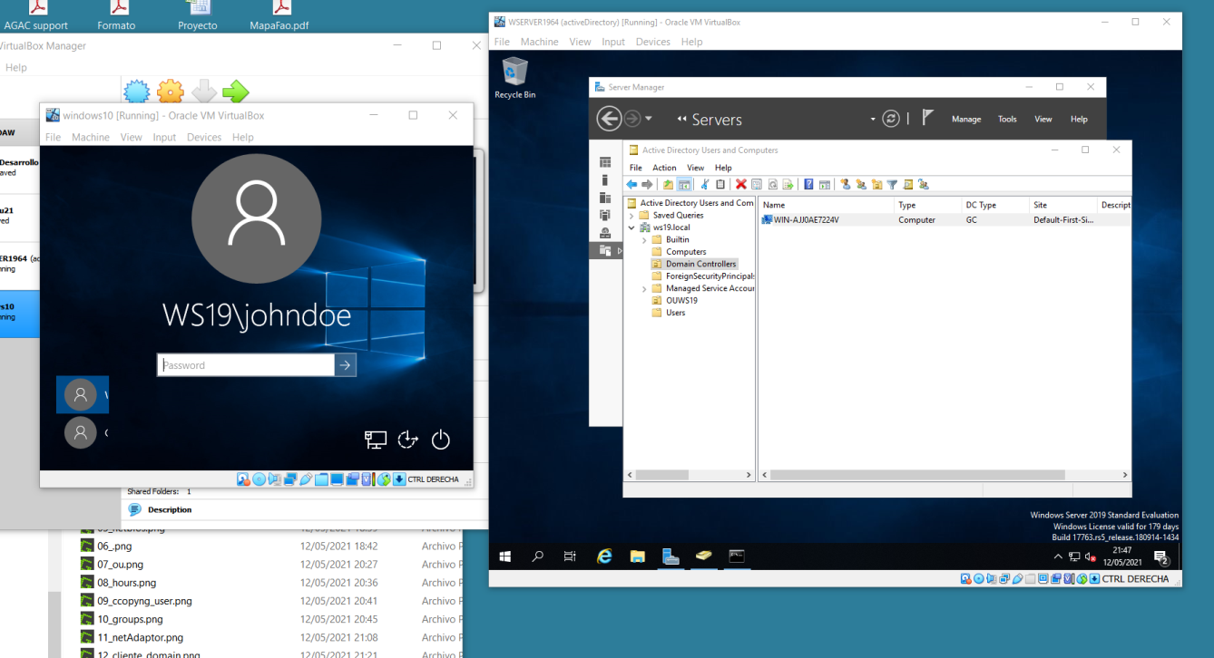

Check that you can log in with the users called **johndoe** and **janeroe**.

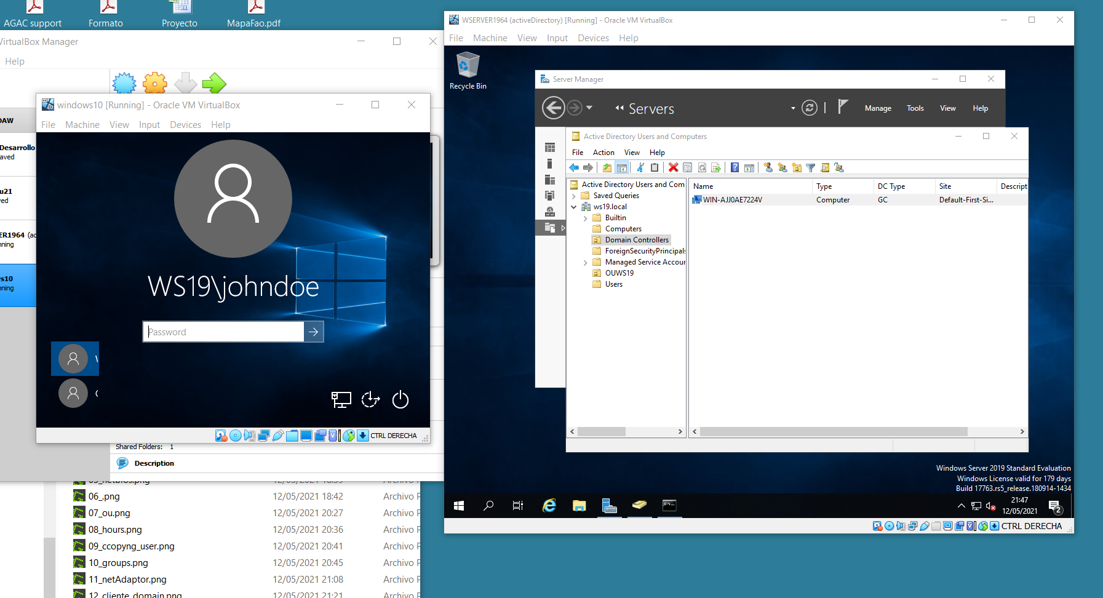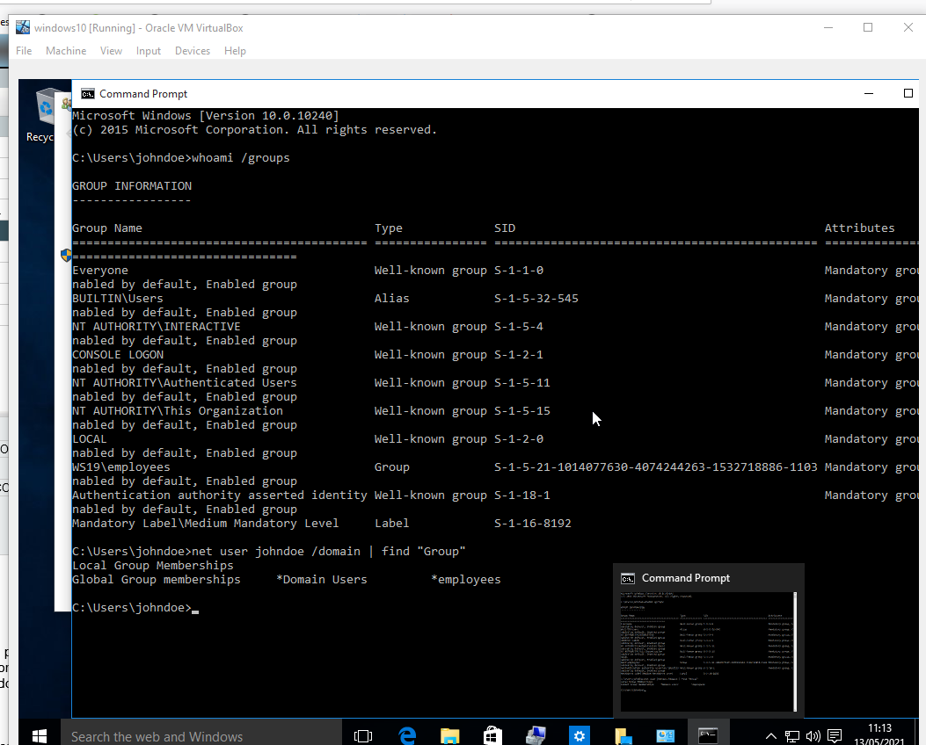

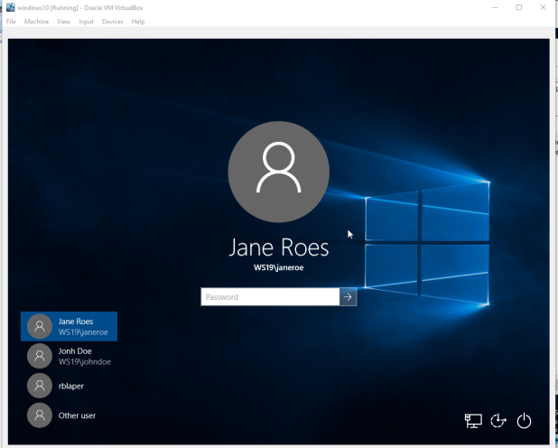 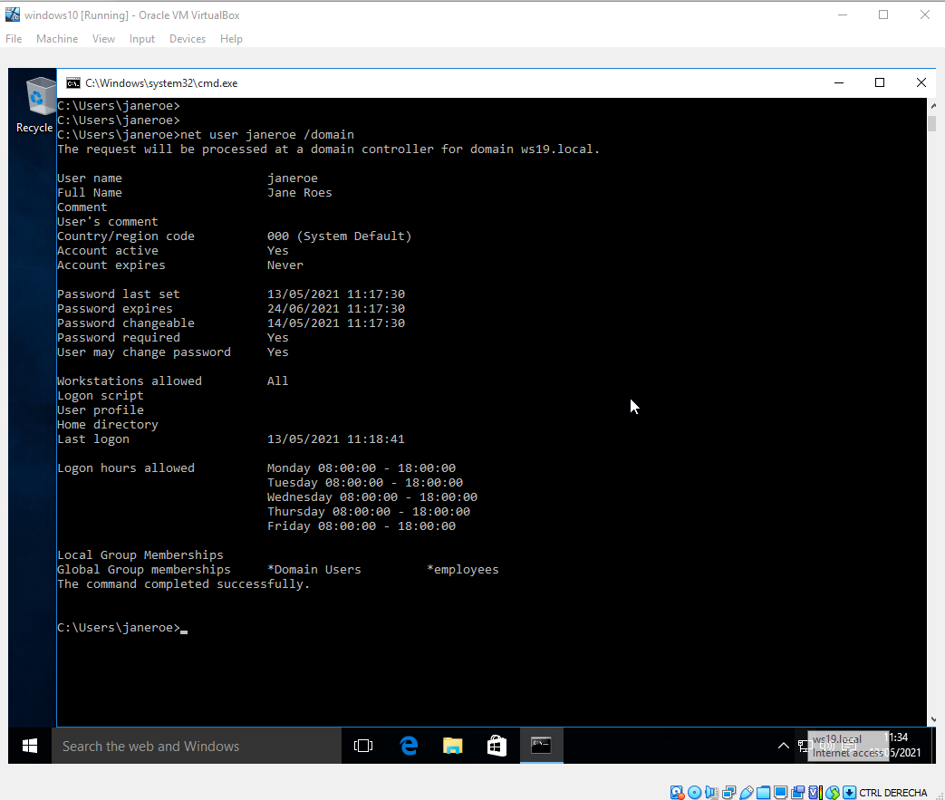

Check the groups these users belong to in the client.

